**LiFi Communication**

*1 Conjeevaram Shravan, 2 Gagan Patil, 3  Gururaj CS*

***ABSTRACT*:** Wireless technology has bloomed to a great extent that it requires wireless technology to transmit a lot of data every day. Nowadays, wireless communications have become important in communication process. The main way to transmit wireless data is by using electromagnetic waves i.e., radio waves. However, radio waves can support less bandwidth because of compact spectrum availability and intrusion. Solution to this is data transmission using Visible Light Communication (VLC). Wi-Fi deals with wireless coverage within premises, whereas Li-Fi is perfect for high compactness wireless data coverage in defined area and for mitigating radio interference issues. In Li-Fi basically we focus to transmitting data between two terminals using LED’s. Li-Fi is a transmission of data through illumination, in which data can be sent through a LED light bulb that varies in intensity faster than human eye can follow. Lifi also supports encryption The light which we are using in our daily life is can also be used for communication by illumination. Transmission of numbers, symbols, alphabets through LiFi technology are done. This method can also be extended to transmit image or audio. Using visible light for data transmission including many advantages and eliminates the disadvantages of transmission of data through electromagnetic waves.

***Keywords***: *LiFI, Wifi, Ethernet, Wireless Communication, Light dependent resistor(LDR)*

**I.INTRODUCTION**

LIFI (Light Fidelity), known as wireless visible light communication, also known as the optical fidelity technologies, is a technology for transmitting data using light bulb light. LiFi is based on Visual Light Communication (VLC) that using light emitting diodes (LEDs) to fully networked wireless system. since LEDs are used, there can technically be any number of access points. This technology uses a part of the electromagnetic spectrum that is still not greatly utilized.

**II.OBJECTIVES**

The main objectives of Lifi Communication as presented in this article are:

• The prime objective of the project is to create an application that transmits data be it text or audio using Li-Fi technology for coping with the limited bandwidth problem we face in RF (Radio frequency) signals.

• For better, efficient, secure and a faster connection Li-Fi is used. One of the advantages of using Li-Fi over Wi-Fi is that it avoids radiation produced by Wi-Fi.

• The goal of our project is to transfer data with faster speed which is not easy to achieve through Wi-Fi and see whether transmission is possible through various mediums or not.

• Li-Fi can be thought as an alternative for Wi-Fi which uses light as a medium to transmit data. We aimed at the transmission of data via Li-Fi and all the possible aspects of transmitting data via light through various mediums which will give us a broad idea of where and how we can use Li-Fi for transmission of data

**III.LITERATURE SURVEY**

R.Mahendran-Integrated Lifi [1] Wireless technology has bloomed to a great extent that it requires wireless technology to transmit a lot of data every day. Nowadays, wireless communications have become important in communication process. The main way to transmit wireless data is by using electromagnetic waves i.e., radio waves. However, radio waves can support less bandwidth because of compact spectrum availability and intrusion. Solution to this is data transmission using Visible Light Communication (VLC). Wi-Fi deals with wireless coverage within premises, whereas Li-Fi is perfect for high compactness wireless data coverage in defined area and for mitigating radio interference issues. In Li-Fi basically we focus to transmitting multimedia data between two terminals using LED’s. Li-Fi is a transmission of data through illumination, in which data can be sent through a LED light bulb that varies in intensity faster than human eye can follow. The light which we are using in our daily life is not only used for providing light but also for communication by illumination.

Vinnarasi, 2S.T. Aarthy et al. [2] With the onset of modern communication, and the increase in the bandwidth usage that led to its congestion, it is paramount that we find an alternative or a faster means of communication. Light Fidelity – more commonly referred to as Li-Fi- is one such concept that is gaining momentum to become the possible alternative. In Li-Fi, the data is transmitted in several bit-streams through high-speed flickering of the LED bulb and decoded on the receiver side which consists of a photodetector. This happens in the form of a binary transmission of data, where ‘0’ is the LED in its ‘off state’ and ‘1’ is the LED in its ‘on-state’. In this paper, we use this concept to transmit data to demonstrate the use-cases and the possible impact it can have in the ever-growing field of communication. In this paper, we transmit two types of data using Li-Fi: Audio and Text

Ayat Nanda. Et al.[3] This paper attempts to clarify the concept and applications of Li-Fi technology. The current Wi-Fi network use Radio Frequency waves, but the usage of the available RF spectrum is limited. Therefore, a new technology, Li-Fi has come into picture. Li-Fi is a recently developed technology. This paper explains how array of LEDs are used to transmit data in the visible light spectrum. This technology has advantages like security, increased accessible spectrum, low latency efficiency and much higher speed as compared to Wi- Fi. The aim of this research paper is to design a Li-Fi transceiver using Arduino which is able to transmit and receive data in binary format. The software coding is done in Arduino- Uno platform. Successful transmission and reception of data(alphanumeric) has been done

Monica Leba; Simona Riurean; Andreea Lonica et al.[4] Important research efforts have been directed over the past ten years, towards exploring alternative parts of the electromagnetic spectrum that could potentially offload a large portion of the network traffic from the overcrowded radio frequency (RF) domain. Due to the latest improvements, the optical wireless communication (OWC) proves to be a viable alternative solution to the issues of forthcoming radio frequency RF spectrum crisis, especially in certain places and situations. Currently, most mobile data traffic is consumed indoor, where light fidelity (LiFi) which is related to visible light communication (VLC) offers lots of specific advantages, and effective solutions to the many issues of wireless communication. The current paper summarizes most of the research, developments and applications achieved so far and looks at the different aspects of the strengths and weaknesses, implementations, challenges, VLC IEEE standard and data modulation techniques of the VLC and specific LiFi's new coined optical wireless communication technology.

Nischay et al.[5] Li-Fi stands for Light Fidelity. The technology is very new and was proposed by the German physicist Harald Haas in 2011 TED (Technology, Entertainment, Design) Global Talk on Visible Light Communication (VLC). Li-Fi is a wireless optical networking technology that uses light emitting diodes (LEDs) for transmission of data. The term Li-Fi refers to visible light communication (VLC) technology that uses light as medium to deliver high-speed communication in a manner similar to Wi-Fi and complies with the IEEE standard IEEE

S. M. Tanvir Abid et al. [6] This system uses a cane which is made up of hollow plastic pipe. To detect water, a water sensor has been placed at the bottom of the cane. 15 cm above ground level, aHC-SR04 (ultrasonic sensor) has been placed which is used here for measuring the distance from the obstacles. A speaker connected with an mp3 player audio module gives sound alerts to the user.It also helps in detecting the darkness; in case the blind person enters a dark area, an alert for the same will be there. If the cane gets dropped from the hand, then it can be easily found using the RF remote in the hand of blind person; By pressing the button on it, a buzzing sound will come from the cane and it can be found easily. The most advanced feature of the cane is the emergency button, which is attached to the GSM and GPS module. By pressing the emergency button, a message with the location of the cane will be sent to their family member(s), so that blind Data transmission is one of the most important term used in our day-to-day activities in the fast-growing world. Li-Fi opens a new era to that. Li-Fi is known as Light Fidelity. Simply it transmits data by visible light. According to recent research Li-Fi has a range of approximately 10 meters. Also, it cannot pass through wall or any solid object. So, this research focuses mainly to increase the 10-meter range. For a regular sized room this range is enough. But if anyone wants to provide data inside a big hall or in any large room, it is not possible by only this range. He must provide more LED that is connected to the Li-Fi router. This research focuses to optimize the number of LED and to minimize the cost. To increase the range of LED two methods are proposed here. One of the method deals with the positioning of the LEDs and another method is to use concave mirror. Smarter way of positioning of light gives better coverage of light that increases the range of LED. As concave mirror gives real and increased mirror for a particular positioning of an object, which is proved both theoretically and mathematically.

FN Division, TEC.[7] Li-Fi stands for Light Fidelity. The technology is very new and was proposed by the German physicist Harald Haas in 2011 TED (Technology, Entertainment, Design) Global Talk on Visible Light Communication (VLC). Li-Fi is a wireless optical networking technology that uses light emitting diodes (LEDs) for transmission of data. The term Li-Fi refers to visible light communication (VLC) technology that uses light as medium to deliver high-speed communication in a manner similar to Wi-Fi and complies with the IEEE standard IEEE 802.15.7. The IEEE 802.15.7 is a high-speed, bidirectional and fully networked wireless communication technology based standard similar to Wi-Fi’s IEEE 802.11. This paper focuses on Li-Fi, its applications, features and comparison with existing technologies like Wi-Fi etc. Wi-Fi is of major use for general wireless coverage within building, whereas Li-Fi is ideal for high density wireless data coverage in confined area and especially useful for applications in areas where radio interference issues are of concern, so the two technologies can be considered complimentary. Li-Fi provides better bandwidth, efficiency, connectivity and security than Wi-Fi and has already achieved high speeds larger than 1 Gbps under the laboratory conditions. By leveraging the low-cost nature of LEDs and lighting units, there are lots of opportunities to exploit this medium. Li-Fi is the transfer of data through light by taking fibre out of fibre optics and sending data through LED light bulb

## **IV.TOOLS AND COMPONENT ANALYSIS**

**A.SIMULATION SOFTWARE**

The implementation of the project presented in this article was performed by using the *Proteus 8 Professional* simulation tool.The Proteus 8 professional is a proprietary simulation software tool suite used primarily for electronic design automation. It is used mainly to create schematics and electronic prints for manufacturing printed circuit boards.

**B.LDR SENSOR**

light-dependent resistors are used to detect light levels. The resistance of the LDR decreases with the increase in light intensity. When there is dark and at low light levels, the resistance of an LDR is high and little current can flow through it.

**V.PROPOSED SYSTEM**

The Li-Fi system consists of mainly two parts, the transmitter and the receiver. LED light is used as signal source between two end systems. Data is carried by the modulated light from the LED. The Arduino modulates and demodulates data at transmitter and receiver ends respectively. The transmitter part modulates the input signal with the required time period and transmits the data in the form of 1's and 0's using a LED bulb. These 1's and 0's are nothing but the flashes of the bulb. The receiver part catches these flashes using a photodiode and amplifies the signal to produce the output. Li-Fi is implemented using white LED light bulbs at downlink transmitter. An array of LEDs can also be used for parallel data transmission and different coloured LEDs to alter the LED frequency so that data are encrypted for different frequency.

In our project we first convert the data file to be transferred into a binary stream of 0’s and 1’s which is fed into the Li-Fi TX hardware which transmits this data through light. Intensity of light is modulated to achieve this goal. We set a high threshold voltage as on state and a low threshold voltage as off state. Whenever the LED is in on state it transmits a 1 and when it is in off state it transmits a 0. The switching transistor is capable of toggling the state of led in nanoseconds which increases the speed of transmission to some extent. The LiFi RX after sensing the binary stream sends it to the system where the original data file is retrieved.

**VI.DESIGN AND IMPLEMENTATION**

Here is the block diagram of our complete model,

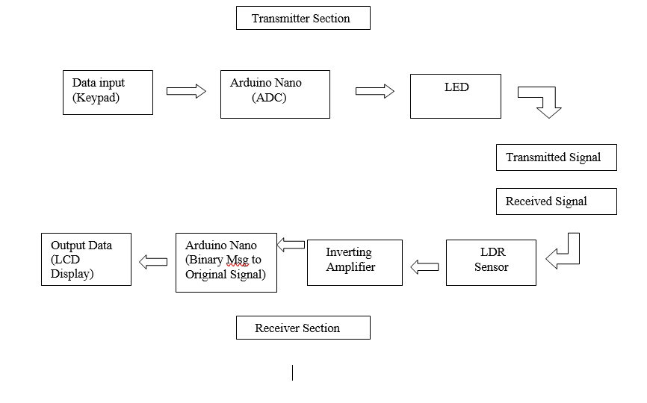

Fig 2.1 block diagram

Transmitter:

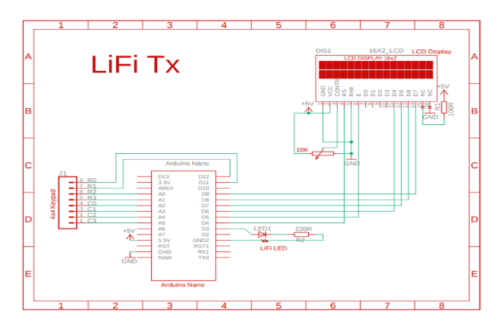

Fig 2.2 LiFi Transmitter

Receiver:

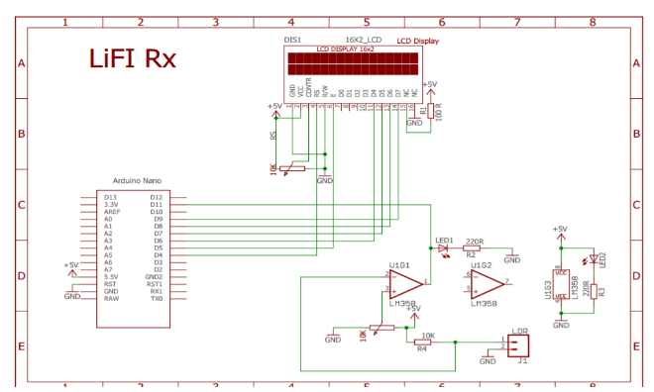

## **VII.RESULT ANALYSIS**

**.**

**.**

**.**

**.**

## **VIII.CONCLUSION AND FUTURE WORK**

.

.

.

..

## **IX.REFERENCES**

* <https://acadpubl.eu/jsi/2017-117-16/articles/17/24.pdf>
* <https://bm-es.com/2018/07/26/diy-lifi-communication-device/>